FIGURES

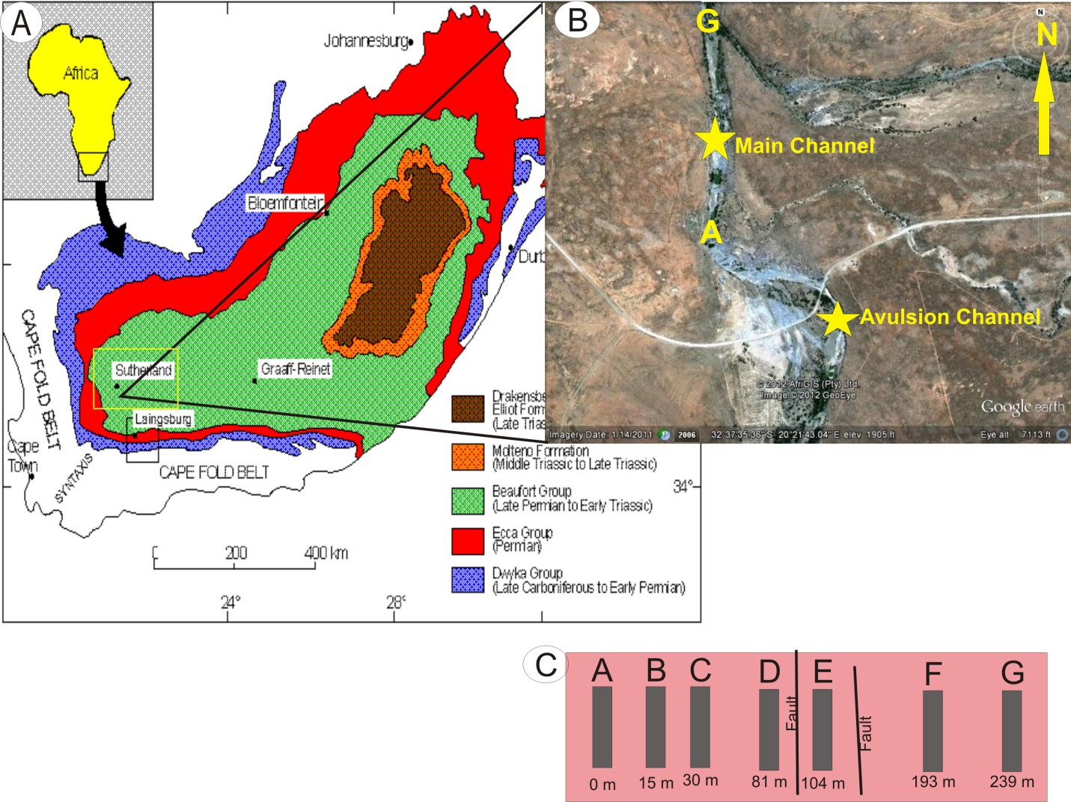
Figure 1: Study location. (A) Geologic map showing the extent of the Karoo Basin (Adelmann and Fiedler, 1996). (B) Google Earth image of the study area south of Sutherland in the Northern Cape Province, South Africa (S32° 37.6’, E20° 21.5’) showing outcrops of the main and avulsion channels approximately 232 m apart exposed by modern river down-cutting . Letters A and G denote the ends of the outcrop used in the current study. (C) Vertical sections A-G used as field description and sample collection locations. Cumulative distance along the outcrop is shown at the bottom of each section. Section E is a down-thrown block bounded by faults that occurred post deposition of the strata.

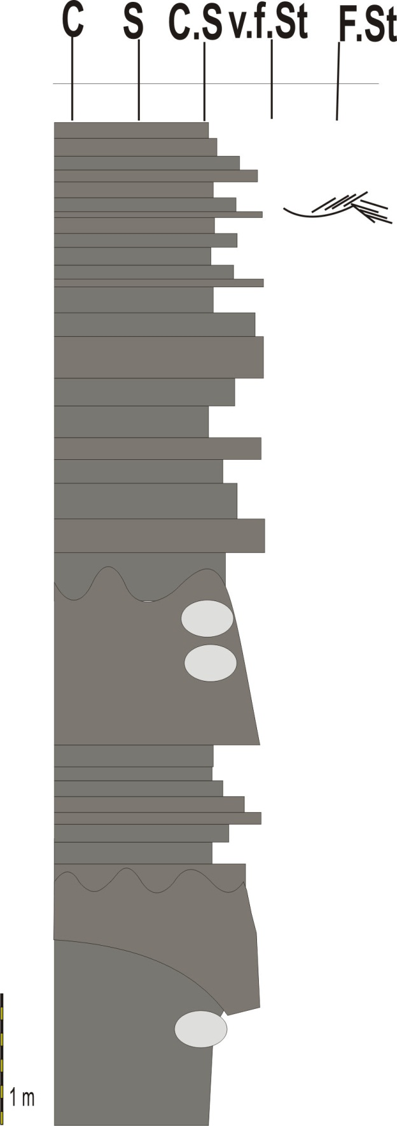
Upper fining upwards Lithic Wacke Facies
Basal Interbedded Heterolithic faices
Capping Coarse Siltstone facies
Upper Interbedded Heterolithic facies
Basal fining upwards Lithic Wacke facies
Basal Coarse Siltstone facies
Figure 2: A representative stratigraphic column showing the different lithofacies in their typical stratigraphic positions.
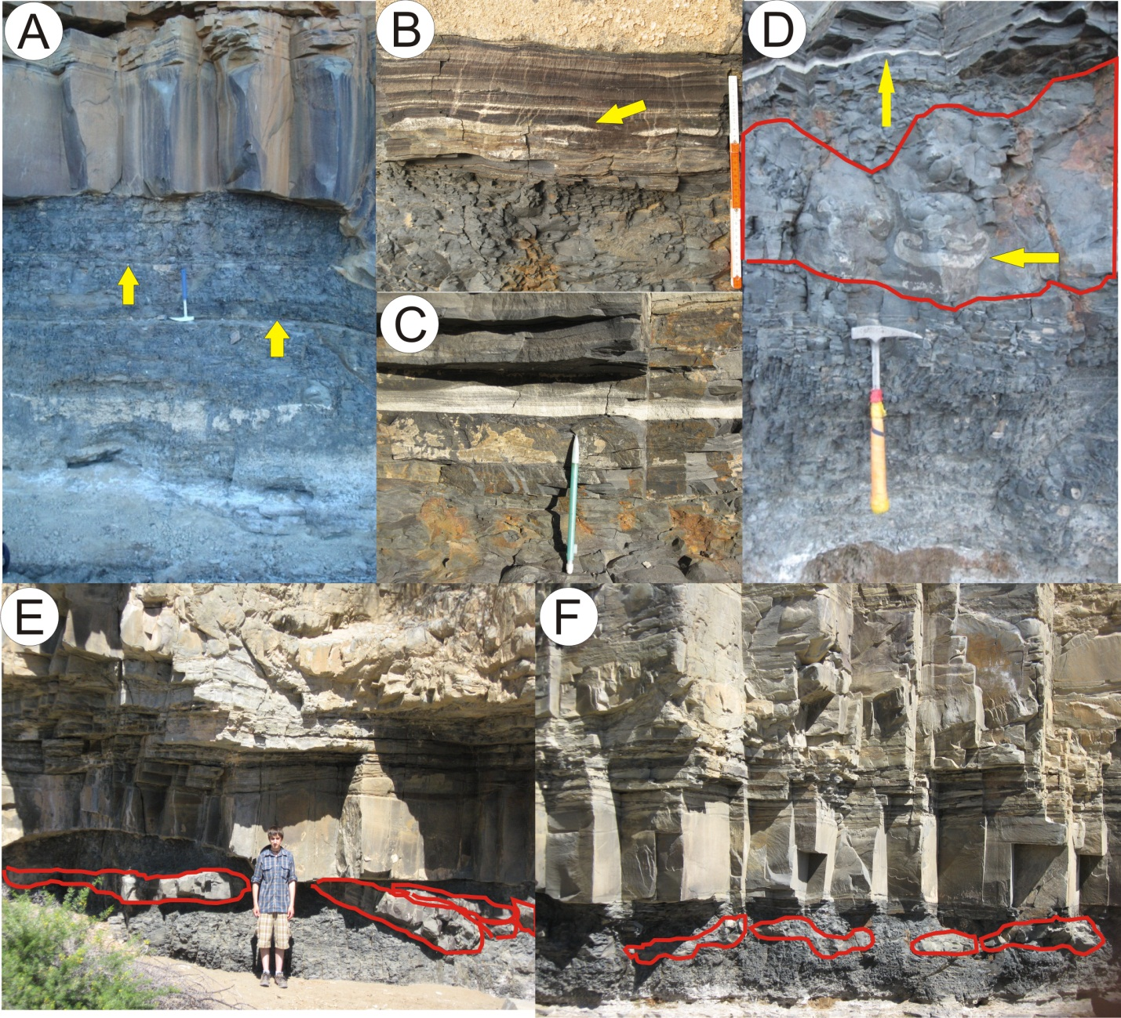
Figure 3: Field photographs from the basal Coarse Siltstone facies. (A) An 1.8 m thick section of horizontal laminated coarse siltstone; rock hammer for scale. Arrows point to pronounced bedding. (B) Upper bounding surface, cm-scale ripple packages, arrow points to starved sand ripples. (C) Close-up of ripple packages near upper bounding surface, location for hand samples 011610.3 a, b, and c (Table 1). Pencil (15cm) for scale and points at starved sand ripple, location for sample 011510.7. (D) Ball structure; arrow points to convoluted internal bedding, upper arrow points to ripple packages shown in (C), rock hammer for scale. (E- F) Ball-and-pillow structures highlighted in red, field assistant (160 cm) for scale.

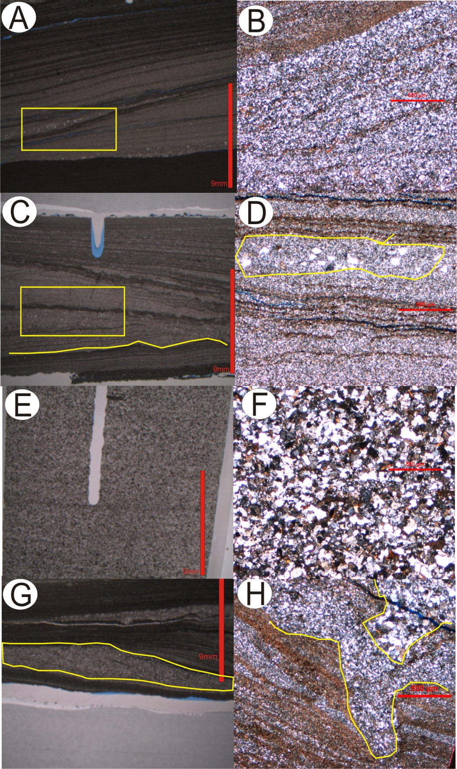
Figure 4: Thin section and photomicrographs of samples from basal coarse siltstone facies. (A) Thin section 011610.3a shows siltstone cross beds and sand clasts at the bottoms of sand ripples. (B) Photomicrograph 011610.3a shows micro-scale cross-bedding. (C) Thin section 011610.3b where yellow line highlights ripple bedding and (D) Photomicrograph of rectangular section highlighted in (C) where prominent sand-sized grains in starved ripples are shown. (E) Thin section 011510.7, showing low-angle cross-bedding and planar bedding, and (F) photomicrograph 011510.7 showing no obvious bedding. (G) Thin section 011610.3c highlights starved sand ripple, and (H) Photomicrograph 011610.3c highlightS micron-scale erosion of siltstone laminae by sand-sized particles, this area occurs on the right side of thin section (G) but is not shown here.

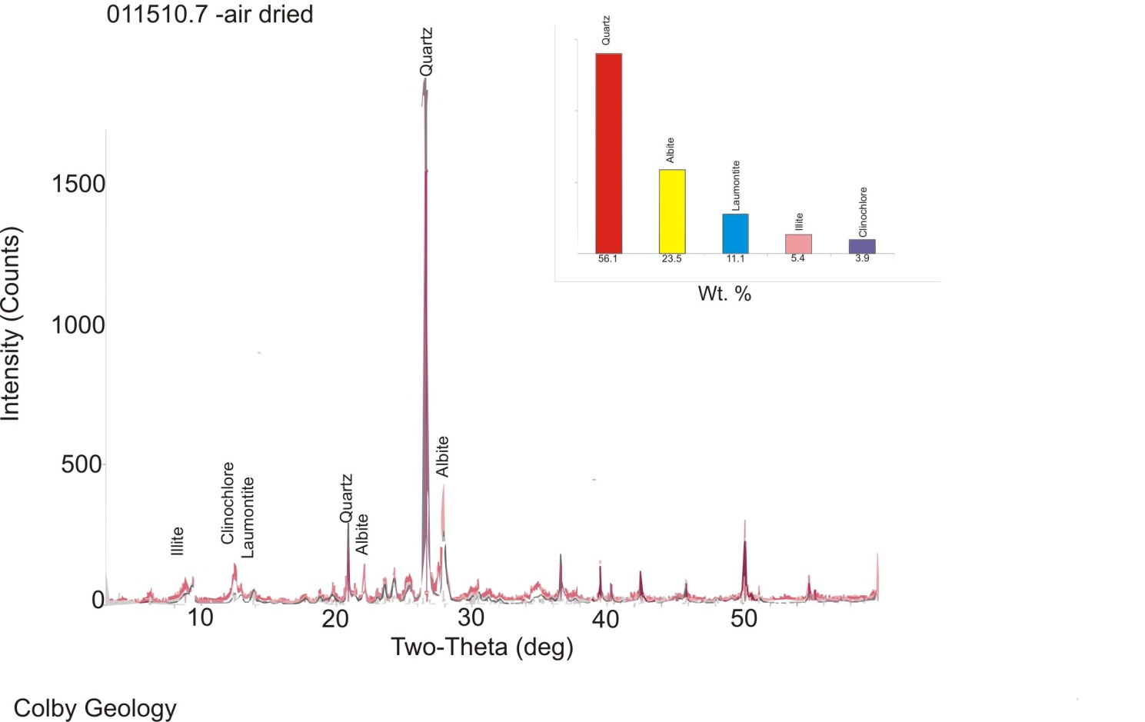
Figure 5: X-ray diffraction pattern for sample 011510.7 of a starved sand ripple in the basal Coarse Siltstone facies. Mineral abundances by weight percent are shown in the bar graph at the top right: Quartz 56.1%, Albite 23.5%, Laumontite 11.1%, Illite 5.4%, and Clinochlore 3.9%. Note: peaks do not represent amount of mineral rather intensity of the peak serve as a guage of confidence for the presence of a mineral.

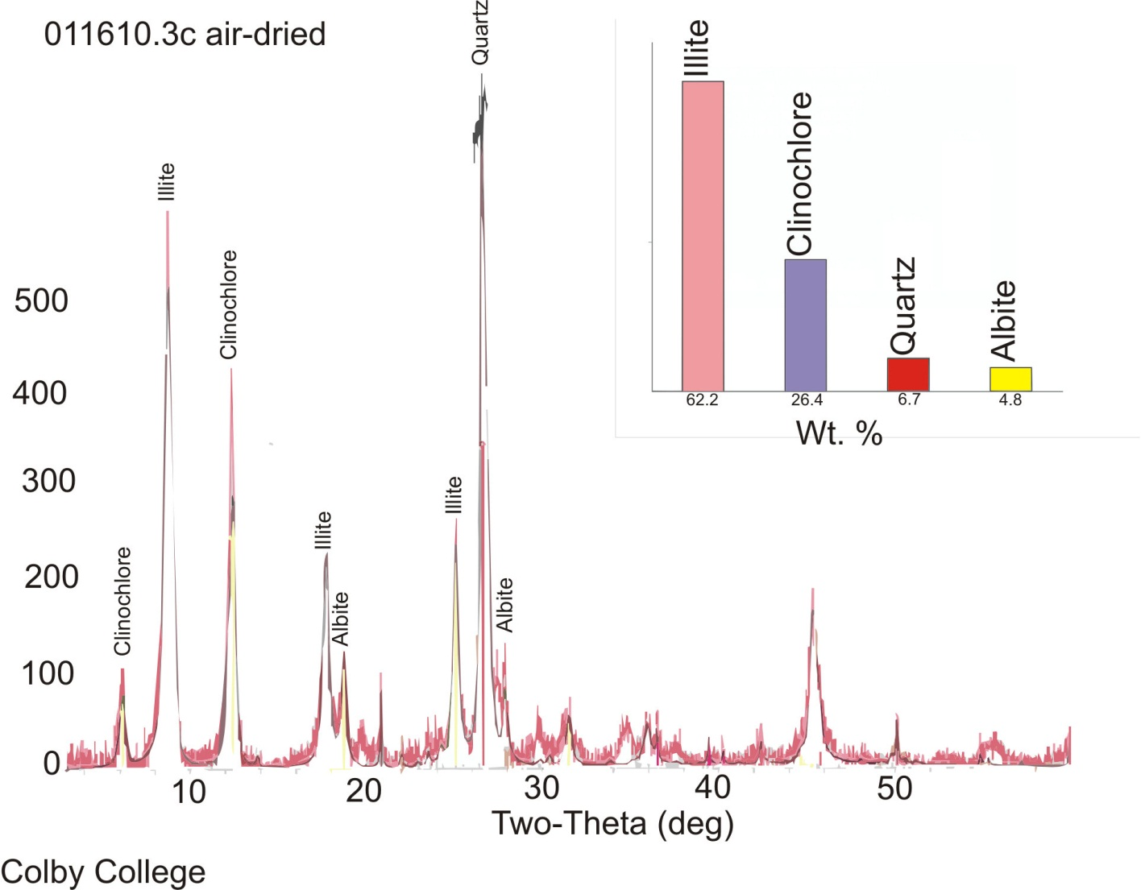
Figure 6: X-ray diffraction pattern for sample 011610.3c, one of the Coarse Siltstone ripple packages near the upper bounding surface of the basal Coarse Siltstone facies. Mineral abundances by weight percent are shown in the bar graph at the top right: Illite 62.2%, Clinochlore 26.4%, Quartz 6.7%, and Albite 4.8%. Note: peaks do not represent amount of mineral rather intensity of the peak serve as a guage of confidence for the presence of a mineral.

Figure 7: Capping coarse siltstone facies. (A) A 70 cm thick section of fine-laminated coarse siltstone scale in decimeters. (B) Upper contact of capping coarse siltstone with subsequent channel sandstone, rock hammer for scale. Photographs show the variation in thickness of this unit.
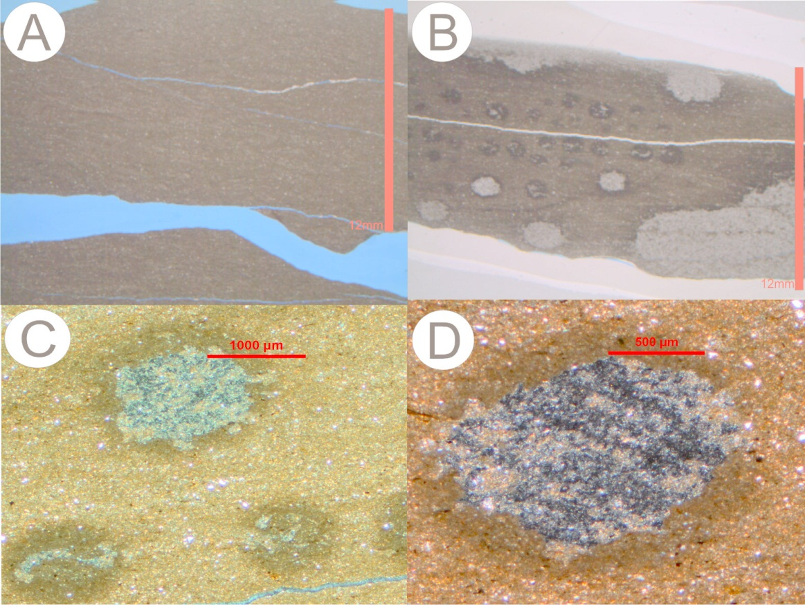
Figure 8: Sample 011510.6 from capping Coarse Siltstone facies. (A-B) Thin sections (scale 12 mm). (C-D) Photomicrographs. (A) Shows fissile character of facies due to thin laminated bedding. (B) Circular and oblong patches later examined in SEM and shown to be carbon-rich. (C-D) Close-up of patches shows chemical alteration halo around patches (scale 1000 µm and 500 µm .

Figure 9: SEM backscatter image, spectrum, and element abundance table for whole patch from sample 011510.6 of the capping Coarse Siltstone facies. Elements are based on K-alpha peaks, measured by weight % (Wt. %), and At. % corresponds to the atomic weight percent. Analyzed area is marked by red oval in the backscatter image. The spectrum and table indicate that Carbon is a significant component besides Silicon, Oxygen, and Aluminum. There are also trace amounts of Titanium.
Figure 10: SEM backscatter image, spectrum, and element abundance table for dark spot on patch (marked by red circle backscatter image) from sample 011510.6 of the capping Coarse Siltstone facies. Elements are based on K-alpha peaks, measured by weight % (Wt. %), and At. % corresponds to the atomic weight percent. The spectrum and table indicate that the area examined is over 50 Wt. % Carbon by composition, and contains traces of Sulfur.

Figure 11: SEM backscatter image, spectrum and element abundance table for light spot on patch (marked by red circle on the backscatter image) from sample 011510.6 of the capping coarse siltstone facies. Elements are based on K-alpha peaks, measured by weight % (Wt. %), and At. % corresponds to the atomic weight percent. The spectrum and table indicate that the composition is similar to the whole patch with the exception of Carbon and Calcium, which are absent.

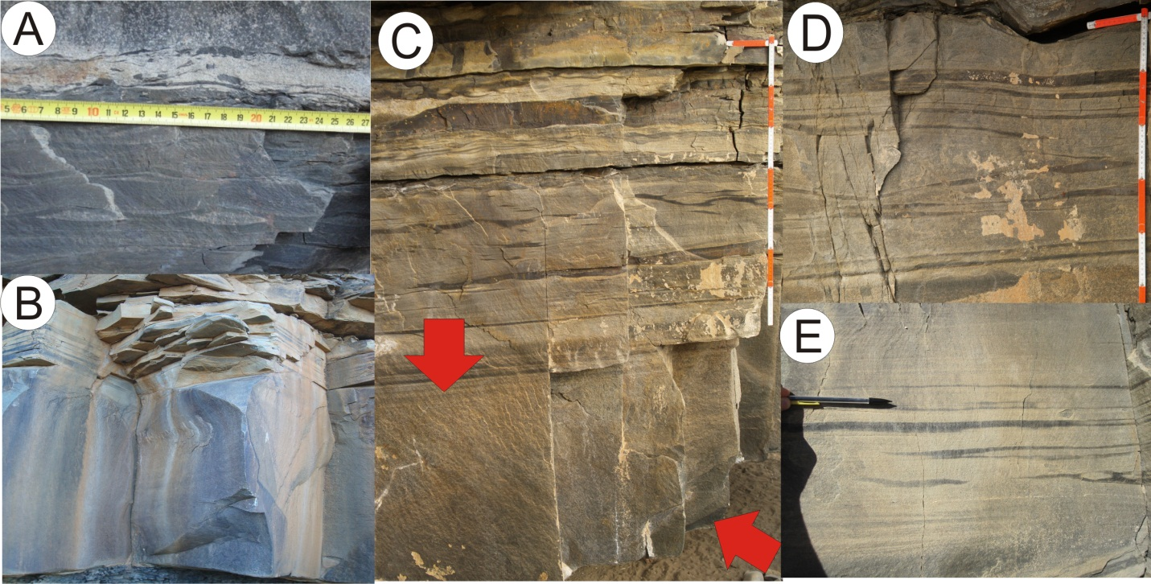
Figure 12: Field photographs of basal fining upwards Lithic Wacke facies. (A) Lower bounding surface with basal Coarse Siltstone facies; siltstone rip-up clasts shown above the measuring tape (scale in cm). (B-C) (same scale) Sharp to gradational upper bounding surface with overlying interbedded facies. This image also shows the massive-looking nature of this facies. Red arrows in (C) delimit the facies thickness in the particular locality (scale in decimeters). (D) Low-angle cross-bedding with siltstone drapes, as well as meso-scale ripple bedding (scale in decimeters). (E) Higher resolution photograph shows low-angle and planar bedding, siltstone stringers in the troughs of meso-scale sand ripples, and planar and low-angle cross bedding. Pencil (14 cm) for scale.

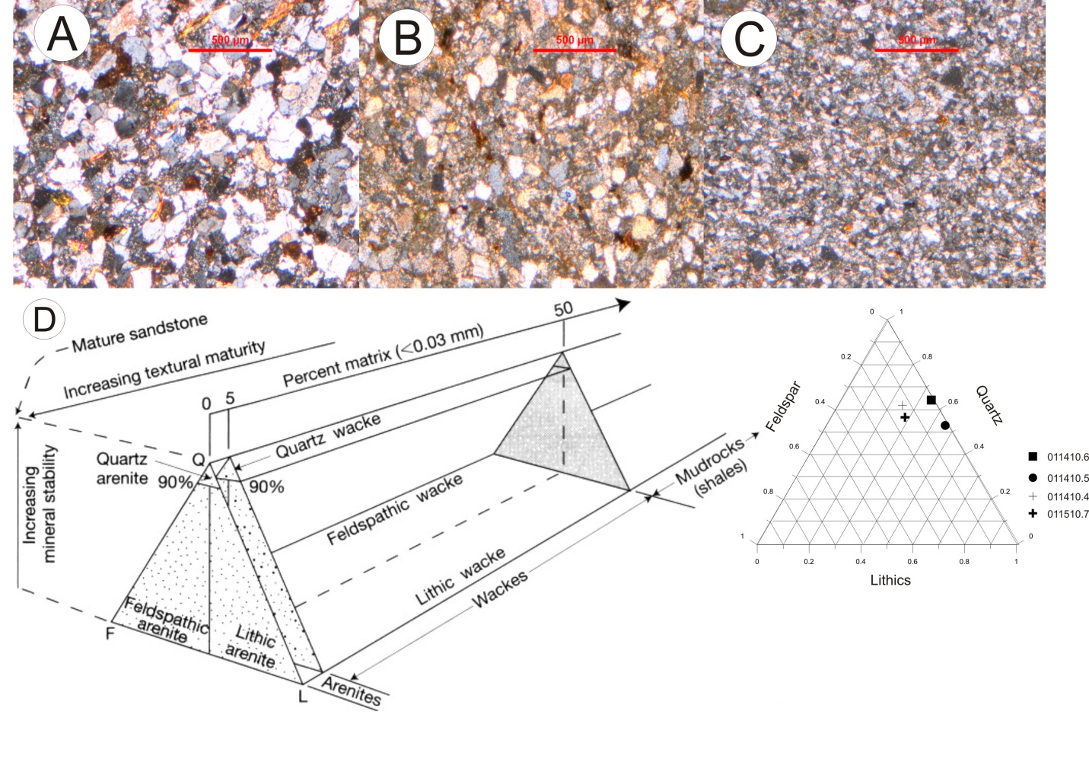
Figure 13: Photomicrographs of basal fining upwards Lithic Wacke facies. (A) Sample 011410.4, (B) Sample 011410.5, and (C) Sample 011410.6. Samples were taken in vertical stratigraphic succession. The grain size significantly decreases over a thickness of 1m (Table 1 and Appendix A and B), thus showing the fining upwards characteristic of the basal sandstone facies. (D) Sandstone classification scheme from www.earth.rochester.edu , on the right shows a ternary diagram of sandstone petrography (this includes sample 011510.7 from basal coarse siltstone facies) (Table 1, and Appendix C). Samples plot as lithic wackes.

Figure 14: Field photographs of upper fining upwards Lithic Wacke facies. (A) A 1.5 m interval showing massive characteristic, rippled lower and upper contacts (scale in decimeters). (B) At least 3 massive sandstone intervals each with rippled bounding surfaces (rock hammer for scale). C) Close-up of boxed section from (C) shows symmetrical ripples (scale in decimeters). (D) Upper contact, arrow points to ripple crest, indicating meso-scale ripple structure, part of rock hammer handle for scale (~15 cm). (E-F) Load structures in thickest part of channel, arrow in (E) points to flame structure between ball-and-pillow structures. (Same scale as Figure 2 (E- F)).
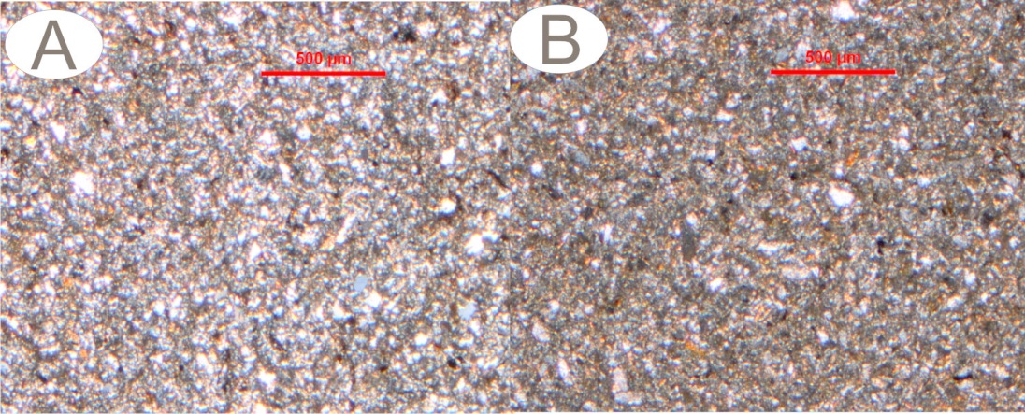
Figure 15: Photomicrographs of upper fining upwards Lithic Wacke facies. (A) Sample 011610.1 and (B) sample 011610.2. These samples were collected near the upper contact at approximately equal stratigraphic height on either side of the fault between sections D and E (Fig. 1 C). There is a marked grain-size difference, but common silt-sized grain dominance. (Table 1, Appendix A and B).

Figure 16: Field photographs of basal interbedded facies. (A) A 1.3 m interval delimited by yellow arrows shows gradational lower contact and sharp upper contact. (B) Close-up of boxed section in (A); arrows point to rip-up clasts at lower contact with underlying sandstone facies. Ruler placed over ripple interval with cm-scale siltstone drapes over sand ripples (scale in decimeters). (C) Upper contact with second sandstone facies; arrow points to siltstone-draped symmetrical ripples above low-angle cross bedding (scale in centimeters). (D) A 1 m section of ripple-interbedded interval, the succession shows an increase in bed thickness up-section, basal ripple laminated sand dominated interval overlain by cm-scale siltstone beds, and a return to thicker sandstone beds with siltstone drapes. Arrow points to asymmetrical sand ripples overlain by a 15 cm thick siltstone bed. (E) Higher resolution photograph of section showing siltstone stringer marking the troughs of sandstone ripples (bottom arrow) and climbing ripples (upper arrow). (F) Another higher resolution photograph near the upper contact of the facies showing an increase in ripple-lamination and siltstone content, arrows point to climbing ripples (scale in centimeters).

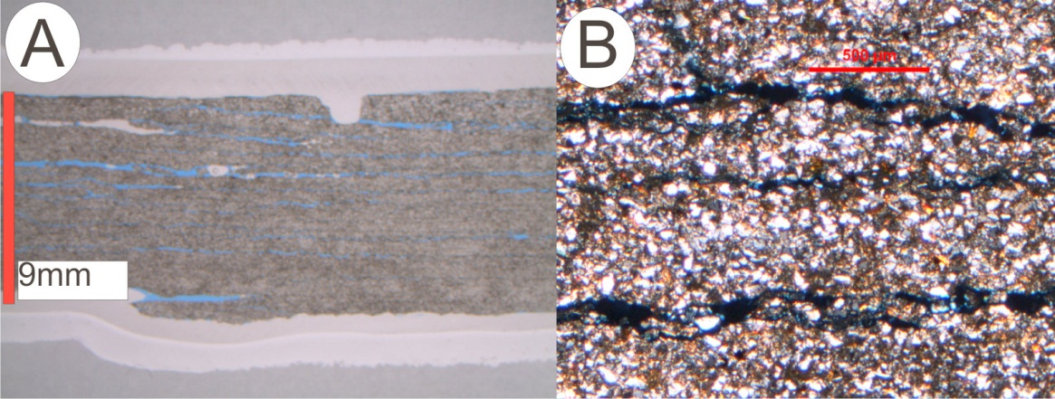
Figure 17: Thin section of sample 011410.7 (A) and photomicrograph (B). Thin section shows low-angle cross bedded lamina. Photomicrograph shows poorly sorting of this lithology. (Table 1; Appendix A and B).

Figure 18: Upper Interbedded Heterolithic facies. (A) A 60 cm interval showing general vertical succession with thick sand dominated intervals at either bounding contact, and a 15 cm thick ripple laminated interval (scale in decimeters). (B) Uppermost contact of this facies is siltstone dominated and grades into the overlying capping siltstone facies (scale in decimeters). (C) Close-up of sandstone interval from (A); arrows point to different bounding surfaces formed by climbing ripples. (D) Close-up of climbing ripple interval in the sandstone dominated sections (scale in centimeters). (E) Arrows indicate small-scale ball-and-pillow structures with convoluted internal bedding in sandstone interval.

Figure 19: Field photographs of ripple surfaces from upper interbedded facies. (A) Current ripples (scale in decimeters), (B) Close-up of current ripples (scale in decimeters), (C) Interference ripples (scale in decimeters), (D) Rain drop impressions highlighted in yellow but also occur throughout the photographed section (scale in decimeters), (E) Horizontal burrows similar to Planolites, and (F) Rose diagram of Southeast paleocurrent direction sourced from wavelength data collected from ripple surfaces in this interbedded facies (See Appendix D).

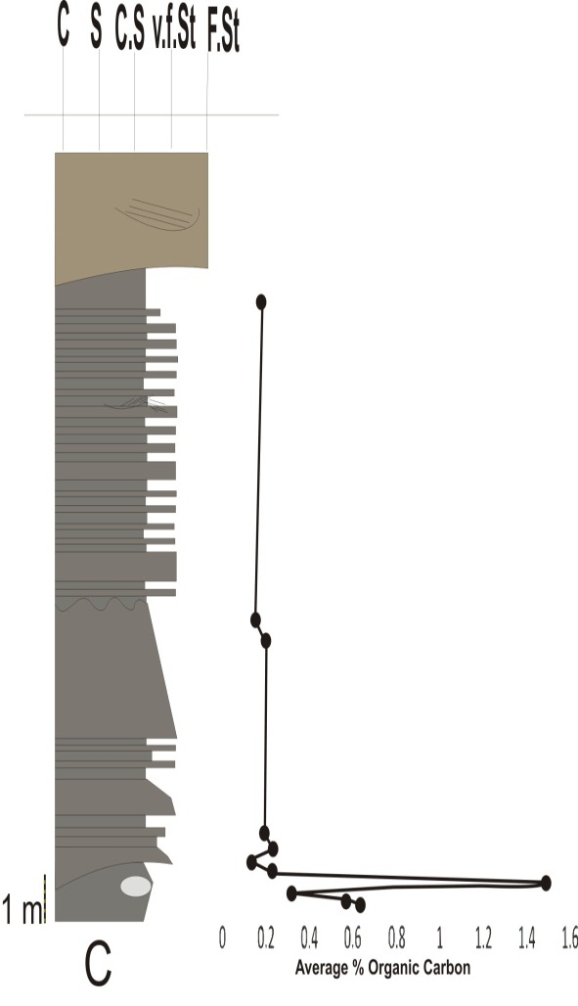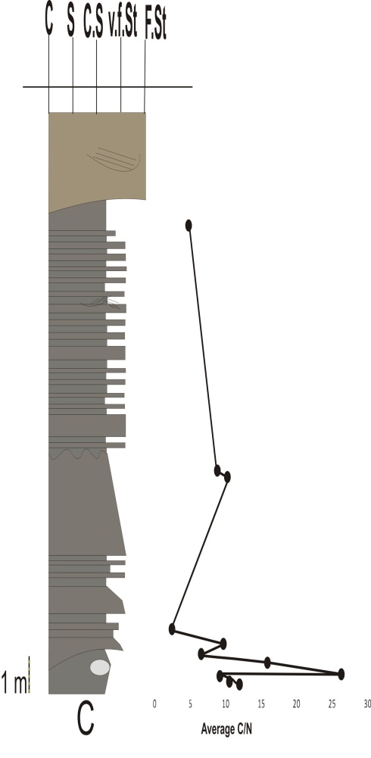
Upper delta plain
Delta front
Prodelta plain
Prodelta plain
Delta front
Upper delta plain
Figure 20: CHN analysis of all 11 samples collected from outcrop, results are ploted against stratigraphic height to show TOC and C/N trends. There is a significant positive excursion in the basal coarse siltstone facies. (Appendix F)

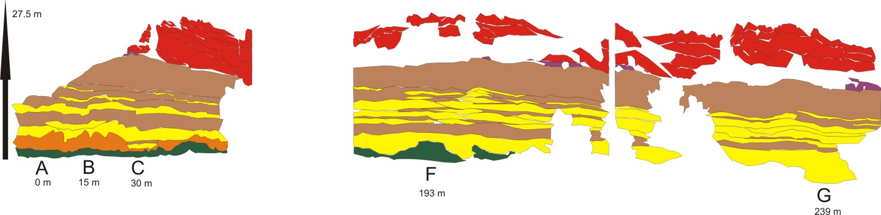
Figure 21: Selected photomosaic tracings with lithologies in Munsell color to show lateral facies relationships. Over 150 m of the outcrop including the downfaulted block is omitted from the diagram. Locations for vertical sections are shown for distance scale. Southern end of outcrop is on the side of section A and section G marks the northern end. While spaces within the illustration denote areas covered over by debris or vegetation.
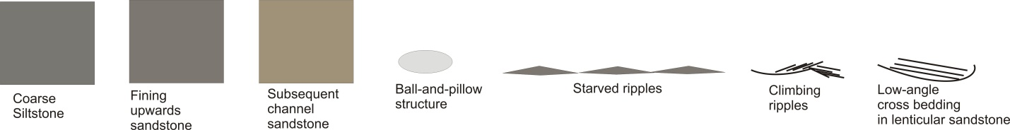 Figure 22: Stratigraphic columns A-G represent vertical sections across the length of the outcrop, assigned to a field assistant for high resolution descriptions. Lines are drawn in to correlate stratigraphic sections. There is a fault between section E is down faulted and the total exposure is 239 m along strike.

